<https://www.youtube.com/watch?v=Ie9myoDh4q8>

<https://bit.ly/3HDBgbA>

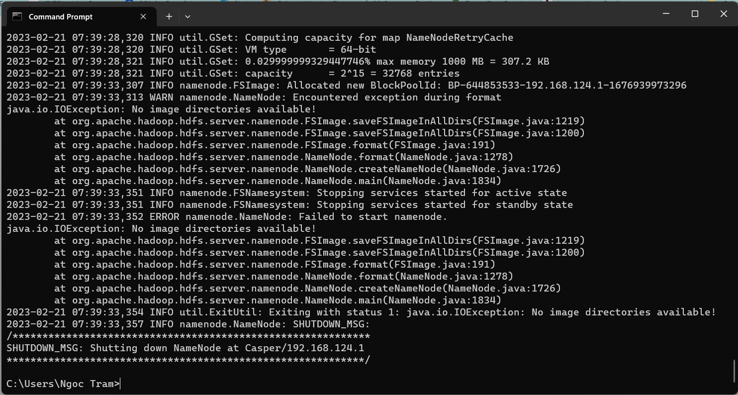

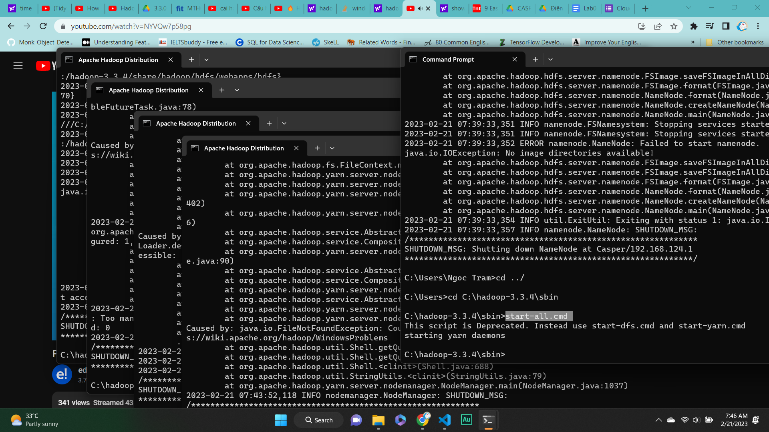

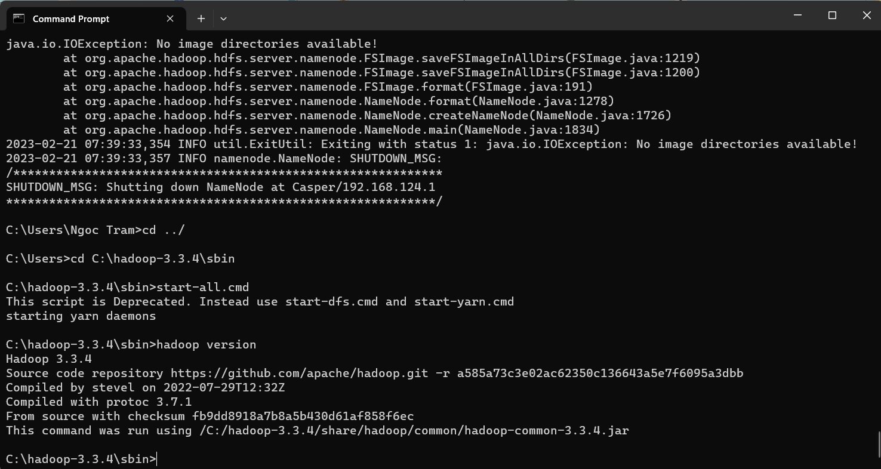

Your data and code (ZIP file).\*

Screenshot captured after running your code.

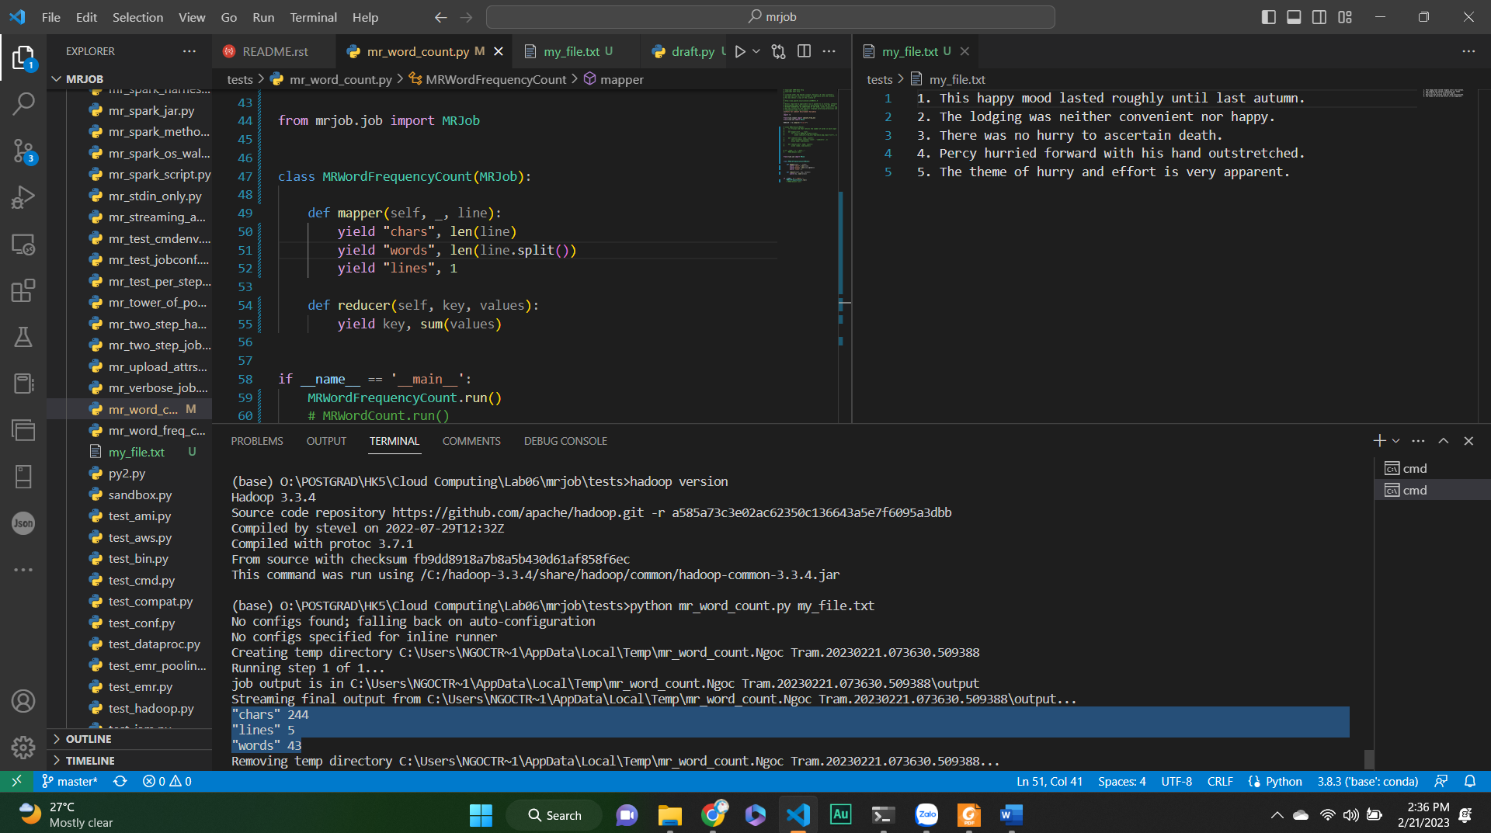

Describe how a MapReduce program runs on 6 machines (1 Master, 3 Mappers, 2 Reducers) using a sequence diagram.

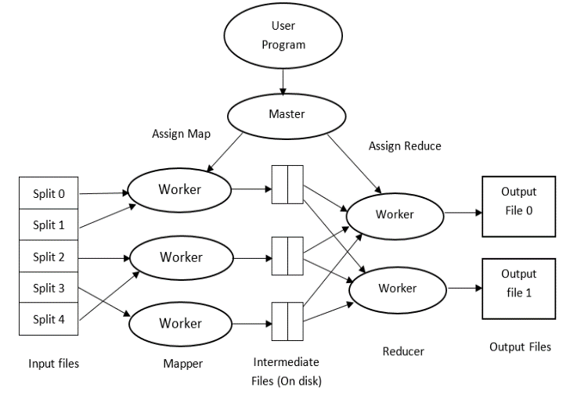

<https://www.youtube.com/playlist?list=PLXWA0mX8UFazM1mVb60cc9EvfWmFvyTjv>